## A PROJECT REPORT

**ON**

# POLLUTION CAUSED BY PETROLEUM INDUSTRY UPSTREAM AND DOWNSTREAM

#### *Submitted in the partial fulfillment of the requirements for the award of the degree*

**Petroleum Engineering**

**In**

**BACHELOR OF ENGINEERING**



***Submitted By* MD.SAHIM ANSARI 18BPE1011 KRISHNA VAMSI 18BPE1015**

***Under Supervision of***

## Ms. SAROJ RANI

### Assistant Professor

**UNIVERSITY INSTITUTE OF ENGINEERING CHANDIGARH UNIVERSITY**

**GHARUAN, MOHALI, PUNJAB, INDIA-140413 APRIL 2019**

## ACKNOWLEDGEMENT

“It is not possible to prepare a project report without the assistance and encouragement of other people. This one is certainly no exception.”

At the very beginning of this project, I would like to extend my sincere and heartfelt duty to all the people who have supported me in this endeavor. Without their active guidance, support, cooperation and motivation, I would not have made any progress in the project.

I am ineffably indebted to my guide Ms. SAROJ RANI for conscientious guidance and encouragement to accomplish this project.

I am extremely thankful and pay my gratitude to our HOD Dr. SAUBHAGYA RANJAN MAHAPATRA for his valuable guidance and support on completion of this project in its presently.

I extend my gratitude to CHANDIGARH UNIVERSITY for giving me this opportunity.

I also acknowledge with deep respect my gratitude to my parents and family friends, who have always helped me both morally and economically.

At last but not the last gratitude goes to all staff members of Department of Petroleum Engineering, Chandigarh University, Mohali who directly or indirectly helped me in the completion of this project work.

Any omission of this brief acknowledgment does not indicate a lack of appreciation.

Thanking You Sahim Ansari Krishna Vamsi

## UNDERTAKING

This is to declare that the project entitled “Pollution caused by Petroleum industry- Upstream & Downstream” is an original work done by undersigned, in partial fulfillment of the requirements for the degree “Bachelor of Engineering.

All the analysis, design and system development have been accomplished by the undersigned. Moreover, this project has not been submitted to any other college or university.

Md. Sahim Ansari Krishna Vamsi

## ABSTRACT

The present paper discusses the main features of the petroleum industry and its overall impact on environmental pollution. The petroleum industry can be mainly divided into two sectors: upstream - exploration, development and production and downstream - processing of hydrocarbons (refineries and petrochemical plants), storage, transport and distribution, retail and marketing. These sectors are capable of generating air emissions, oil spills, waste water, and solid waste.

The description and evaluation of the key sources of pollution from air, waste water and solid waste produced by this industry is given separate attention. There are three immediate tasks at present: to determine the purpose of any environmental assessment, to classify the possible sources of emissions and to choose alternatives to these sources. However, by using as many parameters as possible and making them cumulative, these alternatives need to be analyzed so as to facilitate the classification and evaluation of the best available strategies for each cause of emissions.

**Keywords**: petroleum industry, environment, pollution, hydrocarbons, refineries, emissions, oil spills, solid waste, waste water

## CONTENTS

LIST OF TABLES vi

LIST OF FIGURES vii

LIST OF SYMBOLS viii

1. Introduction *(Heading* 1) Error! Bookmark not defined.
2. Literature Review Error! Bookmark not defined.
   1. *Abbreviations and Acronyms (Heading 2)* 2
   2. *Units* 2
   3. *Equations* 3
3. Material and Methods 1
   1. *Contents* 3
   2. *Figures and Table* 3
4. Results and Discussion **Error! Bookmark not defined.**

4.1……………………………………………………………………………………………

4.2……………………………………………………………………………………………

1. Conclusion **Error! Bookmark not defined.**

5.1 Conclusion…………………………………………………………………………………

5.2 Recommendation………………………………………………………………………………

References **Error! Bookmark not defined.**

## LIST OF TABLES

Table 1.1: Site or area-specific waste management plan

Table 1.2: Potential national declines in federal onshore leases from expanded use of ventilation and flaring technology mitigation technologies

## LIST OF FIGURES

Fig-1: Air emission from petrochemicals refinery

Fig -2: changes in the global energy mix from 2019 to 2040

Fig-3: Blowout in the offhore oil field which set rig on fire and gas flaring

Fig-4: U.S. greenhouse gas emission by gas, 2018

Fig-5: Mauritius oil spill (July 25,2020), the oil tanker MV Wakashio carrying nearly 4,000 metric tonnes of oil ran aground on the coral reef on the southeast coast island

Fig-6: Understanding Risk of Managing Oil and Gas Wastewater

# Introduction

In our day to day lives, oil plays an important role. It is much more than one of the key resources of energy used by humanity. In addition to the key energy sources, it has also acted as a feedstock for many consumer products that play an important role in our lives.

In the other hand, the oil industry has a very significant impact on our climate, causing the greatest potential for hazards at various environmental levels, such as air, water, soil, and causing all living beings on the earth to occur. Pollution is the most significant and threatening result of the operations of the petroleum industry. Pollution is related to all operations, from oil and gas production to exploration and refining activities. These are the few activities that have an effect on our climate, such as gas emissions, waste water, aerosols and solid waste produced during drilling and well production, refining that causes most of the pollution and thus transport.

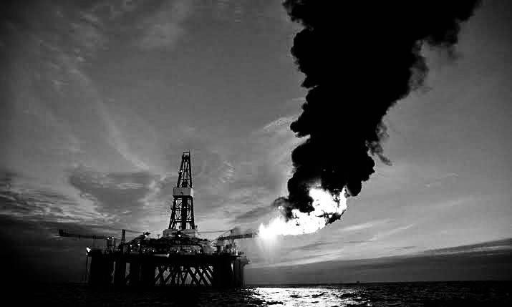In addition to all of this, there are few other environmental impacts that include acid rain, pollution of ground water, greenhousedamage, and low quality of water. Biodiversity and the degradation of habitats are also impacted by the petroleum industry.

For the near future, the global economy would depend heavily on oil and gas resources. The planet absorbs about 100 million barrels of oil a day at present. Right now, approximately 80

percent of the electricity we require is generated by fossil fuels. Electric power, biofuels, hydropower, and other renewables, such as solar, wind and geothermal, are the remaining outlets. Although the International Energy Agency (IEA) aims to expand the usage of renewables, boost energy quality and transition to electric cars, oil will continue to satisfy the growing demand for petrochemicals (used to manufacture regular goods ranging from smartphones torunning shoes) and to power transport.

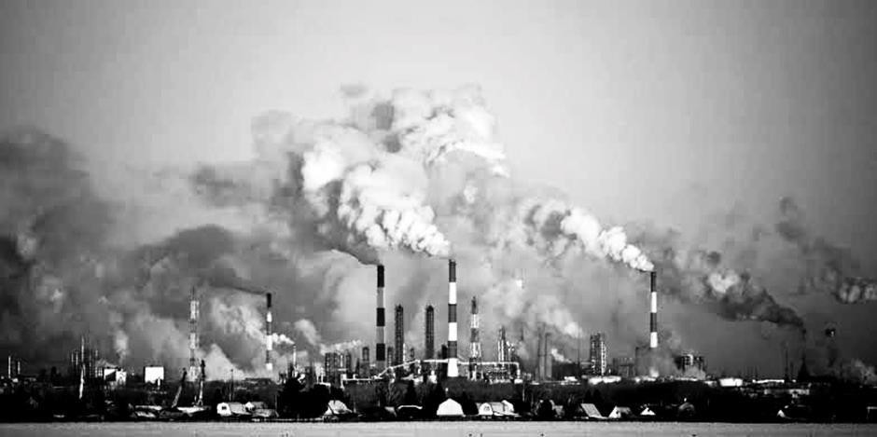

*Fig-1: Air emission from petrochemicals refinery*

Exploitation of deposits of oil and gas has not always been without certain ecological side effects. At different times and locations, oil spills, destroyed land, injuries and explosions, and air and water pollution events have all been reported. In recent years, the social effect of operations has also attracted interest, especially in remote communities. For a long time, the oil and gas industry has struggled to address the challenge of ensuring environmental protection. A ton has already been done, but the industry acknowledges that it is important to do much more.

# Energy Consumptions by the Numbers

The International Energy Agency's annual forecasts indicate that as the world expands and decreases hunger, global energy demand will continue to increase. The IEA is forecasting in its 2020 report that by 2040:

* 1.3 billion: an additional 1.3 billion are projected to rise globally; from 7.7 billion in 2019 to over 9 billion in 2040. Increased demand from emerging markets and developed economies for oil.
* 19%: Global energy demand is expected to rise by 19%
* 2 times more: If it were not for ongoing increases in energy quality, the planet would require twice as much energy as it provides today.
* 29%: 29% rise in demand for natural gas. For inexpensive and efficient electrical power production that emits lower carbon than coal, many nations are searching for natural gas.
* 7%: Overall growth in oil production. While the use of oil for transport will peak, petrochemical development ensures that more oil will be produced in the future.
* 2 percent: The effect of Covid-19 indicates that the number of people without electricity could increase byaround 2 percent in 2020. Latest improvements in access to electricity have been reversed by pandemic impacts. For the first time since 2013, the population without access to electricity could grow by 2020.
* 2023: Global demand for oil is projected to recover in early 2023 to its pre-crisis level.

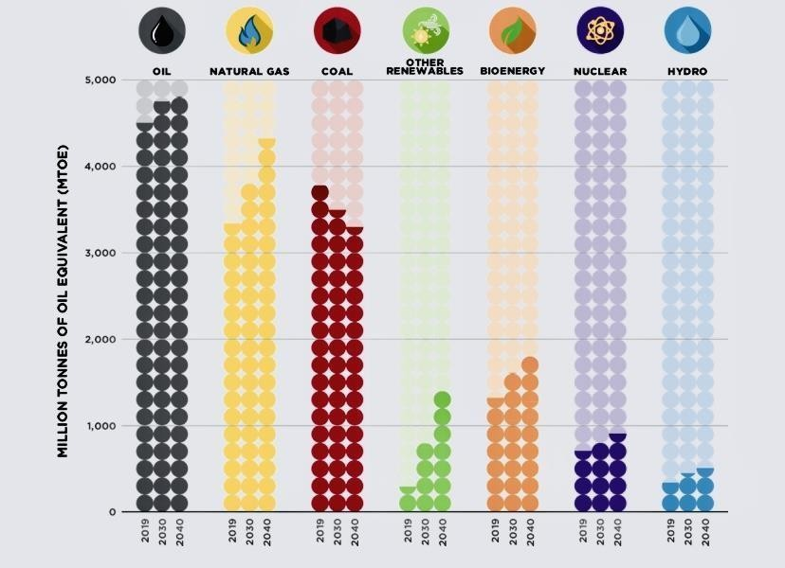

*Fig -2: changes in the global energy mix from 2019 to 2040*

*Sources: International Energy Agency (IEA) 2020 World Outlook, Stated Policies Scenario* As demand for crude oil will rise in near future subsequently it impacts on our environment. Oil and gas consist primarily of two parts: Upstream and Downstream

The exploration and development of oil and gas takes place upstream. Upstream emissions caused by flaring gas, ground clearance, exploration, drilling, feasibility testing and noise from huge machines and disposals of waste solid where as downstream consist of refining, transportation and distribution of crude oil to consumer ends.

# Scope of Work

* Proper preparation and incorporation of environmental problems into infrastructure design, so that the risk of emissions can be reduced.
* Oil spill disaster preparation in order to prevent oil from affecting the coastline and the coastal ecosystem.
* Efficient methods of handling waste and defining waste movement processesand pathways.
* This paper also sheds light on environmental concerns and their industry-related management and offers specifics of the laws, legislation and actions in India.
* Methods of therapy to reduce their atmospheric volume or toxicity.The substitution of other energy supplies.

# Aim of Work

* The goal of this project is to research and provide a broad overview of environmental problems in the discovery and processing of oil and gas and petroleum refining and petrochemical plants, and how they influence the quality of the air.
* To analyse oil spills and injections of harmful substances into or around the source of water.
* Studying techniques of waste management and waste disposal in the oil and gas industry.
* We will also discuss numerous methodologies and solutions that seek to reduce and eradicate the emissions caused by the oil and gas industry.
* Studying both environmental policies and environmental conservation preparation.

# Overview of the Environmental Impact of the Petroleum Industry

The key goalof the petroleum industry is to discover and bring naturalgas and crude oil to the field, to refine it into goods and to sell to consumers petroleum derivatives. The composition of natural gas and in particular, crude oil is a major factor deciding the importance, ease of refining, consistency of the finished goods and the environmental effects of the petroleum industry.

Natural gas: Of the next higher members of the n-alkane hydrocarbons, natural gas is mostly methane with minor volumes. If it absorbs more than 5.7 mg, natural gas is known to be "sour". Hydrogen sulphide in m-3 (H2S). The other primary impurities are carbon dioxide and water.

Crude oil: Crude oils are typically dark and viscous, but their colour and viscosity can differ greatly. 79.5 - 87.3 percent carbon, 10.4 - 14.8 percent hydrogen, 0 - 8 percent sulphur, 0 - 2 percent oxygen, 0 - 0.1 percent nitrogen, and 0 - 0.05 percent metals are seen in the standard element study of crude oils (iron, vanadium, nickel, arsenic, etc.). Hydrocarbons of various molecular masses and types, containing atoms from 1 to 60 C and including several thousand different compounds, are the key components of crude oil. Normal and iso-alkanes, cyclo- alkanes and arenes are the usual hydrocarbon groups in crude oils. A

A large amount of hybrid hydrocarbons was found in heavier fractions, i.e. cycloalkanes and arenes with lateral alkyl chains, combined cycloalkane-arene systems with lateral chains, etc. Crude oil hydrocarbons have natural boiling points ranging from 30 to over 500 oC. Alkenes are not abundant in natural crude oil, but specialized methods can be used to extract them.

The petroleum industry absorbs tremendous quantities of water, especially in the refining and processing industries, but modern refineries operate with a nearly closed water cycle, only compensating for evaporation losses with fresh water. Their biggest contribution to water waste arises from unchecked leakage and dumps, as well as from fuel oil and products during shipping. In this presentation, the contribution of the latter to maritime contamination is the purpose of a separate chapter.

# Sources of Environmental Pollution from the Petroleum Industry

Air pollutants from the petroleum industry can be categorized as combustion emissions, process emissions, fugitive emissions, storing and processing emissions of petroleum liquids and secondary emissions.

Combustion emissions are produced by the combustion of fuels on site, normally for energy production and transport purposes. Flaring is a particular cause of pollution from combustion in the petroleum industry. It is used for pressure management and gas removal, which cannot be used otherwise. Leaking cylinders, pumps, or other process systems emit fugitive gases (equipment leak emissions). In the process units, process pollutants are produced and emitted from process vents. Emissions from the storing and handling of natural gas and crude oil, as well as their intermediate and completed derivatives, lead to storage and handling. The primary cause of secondary pollution is the water systems of a manufacturing or distribution facility (tanks, reservoirs, drains of the sewage system, etc.).

In the petroleum industry, contaminated water is commonly generated in different manufacturing or refining activities. Liquid leakage from refining, mining, distribution facilities or pipes to the ground may also lead to underground water contamination.

Solid wastes containing varying amounts of different pollutants are generated from particular processes or as sludge in storage tanks.

# Pollution from crude oil and natural gas exploration and production

Oil and gas production are a significant activity of the petroleum industry. Worldwide, about 100 countries are interested in it and a large amount of oil and gas is extracted offshore. There are more than 575000 crude oil fields, 252000 coal wells and 724 gas plants in the United States alone.

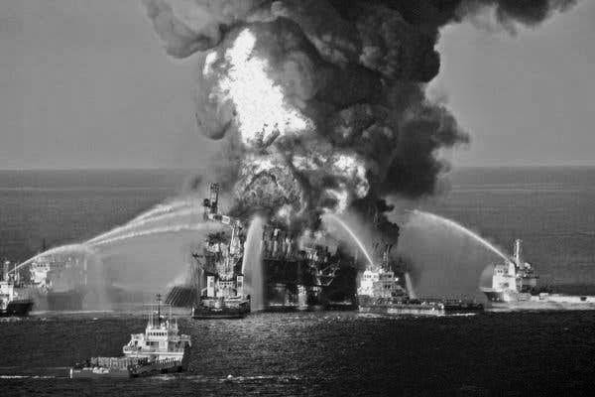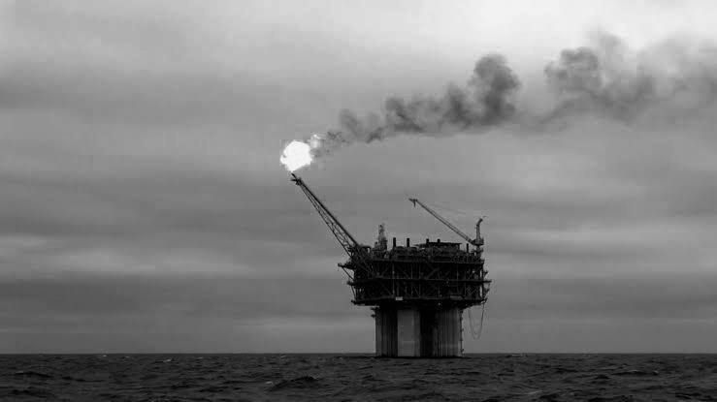

*Fig-3: Blowout in the offhore oil field which set rig on fire and gas flaring*

Exploration and well site planning entail main tasks in this division of the petroleum industry; drilling; development of crude oil and gas, increased (secondary recovery and finally some on- site refining.

Exploration: Oil and gas reservoir exploration involves geological surveys, space, land and sea mapping based on magnetic, gravity or seismic geophysical methods. If incorrectly applied, seismic methods may affect environmental organisms, especially in marine exploration.

Drilling: Drilling typically uses rotary drilling machines powered by internal combustion engines driven by diesel fuel or naturalgas. Drilling muds, which are gel like (non-Newtonian) water-based, oil-based or water-in-oil emulsion-based clay suspensions with additives, allow ground penetration. They can contain polymers, caustic soda, multiple emulsifiers that are ionic or non- ionic, etc. Recultivation of soils is a significant prerequisite for environmental compatibility after drilling.

Oil and gas extraction take place from wells, which are basically pipelines with screwed joints that enter the production formation from the surface of the earth. Tubing is called the pipe from which the oil is extracted and its diameter is between 31 and 115 mm.

Production is regulated primarily for the prevention of "blow-outs" by bottom-hole chokes, pressure gauges and down-hole protection valves, normally accompanied by light fraction ignition.

Enhanced (secondary) methods of recovery are used to lift the amount of crude oil extracted to around 30-40% of the amount in the tank, as only 20-25% of the oil comes out on its own. This involve filling of water-containing salt, injection of high-pressure gas (hydrocarbon gas, CO2, N2, etc being used), boiling of hot gas or steam, or part of the oil being burnt.

On-site processing of natural gas can involve amine acid gas removal and glycol dewatering. On- site crude oil refining typically requires the isolation of water and salts by gravity and the recovery of condensable hydrocarbons. If there is a near-by refinery or other available facility, sulphur recovery and fractionation of light hydrocarbons may be achieved.

Air contamination from the processing of oil and gas is attributed to explosive fugitive emissions of hydrocarbons (primarily methane), as well as emissions from storage and handling. In enhanced oil recovery, the use of gases typically contributes to increased process pollutants, which often come from processing machinery process vents and ultimately from the elimination of acid gases. Exhaust combustion emissions are produced from service vehicle compressors, pumps, drill engines and engines. Flaring gas is the primary cause of pollution from combustion. Water is isolated from natural gas and crude oil and is the main cause of secondary pollution.

The contamination of underground water is typically correlated with improved crude oil recovery and desalination. Nevertheless the water from the desalination at a production plant can be reused in the production well. Solid waste consists mostly of sludge from crude oil desalination and storage vessels, spent mud, etc.

# Pollution from Storage, Manipulation, and Transportation of Petroleum Liquids

Storage, manipulation and transport are practices inherent in all branches of the oil industry. At processing sites and transport terminals, substantial quantities of crude oil and/or natural gas are stored. Production plants store large volumes of crude oil and coal, as well as finished goods.

Collection of liquid petroleum products may be carried out in steel or concrete tanks above ground or underwater, or in salt domes underground, mining caverns, or abandoned mines. Between 16 000 to 121 500 m2 of land may be needed for above ground storage in tanks. The storage site in a salt dome, normally a former salt mine, may have a diameter of up to 10 km. Limited volumes of petroleum products could be stored in tanks for a shorter time. In the case of petroleum goods, storing in specially built steel containers, such as those at gas stations, is common practice.

In pressurized reservoirs, exhausted oil and gas wells, aquifers, salt domes and cavities, etc., natural gas can be processed. Water-sealed gasholders can contain gas of 700 - 285 000 m3. Much smaller pressurized vessels (bottles) are used for domestic purposes.

The most commonly used vessels in the oil industry for the handling of petroleum derivatives are above-ground or underwater steel tanks (pure chemicals and petroleum products from crude oil fractions). For military bases, fuel stations and wholesale bulk storage terminals, underground tanks are the most common.

For organic liquid storage vessels, six simple tank types are used: fixed roof (vertical and horizontal), external floating roof, domed external floating roof (or covered), internal floating roof, variable, vapor space and pressure (low and high).

* Pipelines, tanker ships, rail or road shipping, or inland waterway ships may be used to transport crude oil and natural gas. Tankers are one-fifth of the world's overall commercial tonnage in maritime shipping, and tanker vessels with a size of up to 300 000 tons or more are in service. The connection between the oil field and the refinery or sea-loading terminal can be given by pipelines.

They have electric motors, internal combustion engines or gas turbines powered by an intermediate boost generator or pumping stations. High-pressure pipes with a diameter of up to 1.5 m are used to carry natural gas. The pipeline of crude oil and natural gas can be several thousand kilometres long, spanning numerous countries, mountains and even oceans.

For petroleum derivatives, rail and road transport are typically used while lower pressure product pipelines are typical in most developed countries. In 1996, the overall length of natural gas pipelines exported by the USA was just over four hundred thousand kilometres, while the gas delivery pipelines were over 2.25 million kilometres.

Evaporative hydrocarbon emissions from manipulation - loading/unloading and transit ('breathing') losses from storage tanks and vehicle transport tanks are primarily air emissions from storage and transport. The volume of the gas phase either increases or reduces as the volume of the liquid phase in a tank varies. This refers to the atmospheric release of vapors or the suction of air during loading/unloading. Breathing, which happens in transit as well is the product oftemperature and pressure changes outside the tank. Fugitive pollutants from multiple leaks in suitable facilities also include those from pressurized pipelines.

The largest source of secondary pollutants, but also a significant source of marine water waste, is ballast water from transporting vessels and tankers in particular. Leaking fluids from tanks and reservoirs is the other cause that pollutes underground water.

# Pollution from Natural Gas refining and Crude Oil processing

Natural gas production is typically limited to the de-watering and removal of acid elements such as hydrogen sulphide and, finally, carbon dioxide.

For a small refinery, the production of a crude oil refinery may range from 2000 to 10 000 tons per day (1.8 to 9.0 million tons per year to 20 000 to 60 000 tons per day (18.0 to 54.0 million) tons per year for a large one.

It is estimated that the volume discharged to public water treatment plants or diverted to natural water supplies is between 0.3 and 0.6 m3.

Petroleum refining requires large volumes of water as well. The overall quantity of water used in US refineries was estimated to average 1.5-2.2 m3 in 1992.

Water per one cubic meter of refined crude oil. Inside the refinery, waste water is treated and the bulk of it is recycled.

Water for every 1 cubic meter of oil. The above criteria will be even higher for old refineries in other parts of the globe.

The refining of petroleum also requires vast amounts of chemicals used in various technologies: water handling, fraction processing, additives to finished products, etc. Many of these are classified as chemicals which are harmful. In 1995, hazardous chemicals handled by US refineries were roughly 0.6 million tons.

# Potential impacts on Environment

It is necessary to consider the geographical (global, regional local) scale over which they can occur in determining possible impacts. Similarly, it is important to understand the perception and extent of possible impacts, which would also depend on the acceptability or importance of subjective understanding. In solving the issue, mediation, negotiation and understanding are crucial and can help shift from places of confrontation, dependency or alienation between parties to positions of mutually accepted and recognized interdependence between partners.

### Human, socio-economic and cultural impacts

Economic, social and cultural shifts are expected to be caused by discovery and development activities. The scale of these changes is particularly significant for local groups, especially for indigenous people who may be influenced by their traditional lifestyle. The major impacts can require adjustments in the:

* Land-use practices, such as agriculture, fishing, forestry, hunting, as a direct consequence (e.g. land-use and exclusion) or as a secondary consequence of the provision of new access routes leading to unplanned natural resource settlement and exploitation.
* Local population levels due to immigration (labour force) and distant population relocation due to improved connectivity and possibilities.
* Due to new job opportunities, socio-economic structures- tunities, income differentials, inflation, per capita income disparities, as separate members of local communities benefit unevenly from induced changes.
* Socio-cultural processes, such as social institutions, corporate and cultural history, traditions and values, and secular impacts, such as natural resource impacts, access privileges and shifts in foreign-influenced value systems.
* Access to and access to, products and services brought into the zone, such as accommodation, education, health, water, food, energy, sewage and waste disposal, and consumer goods.
* Strategies for preparation, in the event of disputes between choices and protection, the usage of natural resources, leisure use, tourism and historical or cultural resources;
* Aesthetics, because of installations that are unsightly or noisy.
* Owing to improved path, air and sea capacityand related impact, transportation systems (e.g. noise, accident risk, increased maintenance requirements or change in existing services).

There are also likely to be some positive improvements, especially where careful consultation and collaborations have been established. Improved sanitation, water supply, sewerage and sewage disposal, health care and education are expected to follow, for instance. The unequal distribution of advantages and impacts, however and the inability, especially of local officials, to often anticipate the effects, can contribute to unexpected results. Any, if not all, factors may be affected by proper planning, consultation, administration, lodging and negotiation.

### Atmospheric impacts

Atmospheric challenges are drawing rising attention from both business and government officials around the world. This has led the oil and gas exploration and development industry to work on pollution minimization techniques and technology. It is necessary to consider the origin and significance of pollutants and their relative relation to ambient impacts, both local and those relevant to global problems such as stratospheric ozone depletion and climate change, in order to analyse the possible impacts resulting from exploration and development activities.

The main sources of pollution from oil and gas activity in the environment derive from:

* gas flaring, venting and purging.
* combustion processes such as gas turbines and diesel engine.
* Fugitive emissions from production machinery filling processes and tanks and losses.
* airborne particles from soil disruption during building and from traffic in vehicles.
* Particulates from other causes of fire, such as research wells.

Carbon dioxide, carbon monoxide, methane, reactive organic carbon and oxides of nitrogen are the major greenhouse gases. Sulphur dioxide and hydrogen sulphide emissions can occur and rely on the hydrocarbon and diesel fuel sulphur content, especially when used as a power source. Sulphur content can contribute to odour near the facility in certain instances.

In certain fire safety devices, mainly halons, and as coolants, ozone depleting compounds are used. Following major industry efforts, unplanned pollutants have been substantially minimized.

The most important cause of air pollution is the flaring of generated gas, especially where there is no infrastructure or demand available for gas. However, gas is refined and sold as an essential product where it is viable. Thus, the need for flaring can be significantly minimized by coordinated growth and by creating markets for all goods. Flaring can also occur as a protective precaution on occasions at start-up, repairs or disruption in the regular phase.

### Aquatic impacts

The major aqueous waste sources originating from the processes of exploitation and processing are:

* water produced
* Drilling fluids, cuttings and additives for well treatment
* water collection, cleaning and drainage.
* Sewerage, household and sanitary waste.
* Spills and leakage.
* air cooling.

Waste concentrations are small during seismic activities and are generally connected to camp or vessel operations. Drilling fluids and cuttings are the key aqueous effluents in exploratory drilling, while water is provided in processing activities after the construction wells are finished.

In the literature, the make-up and toxicity of chemicals used in research and manufacturing have been frequently presented, whilst the E&P Forum summarizes waste streams, origins and potential components of environmental significance, as well as methods of disposal. It has been found that water-based drilling fluids have only a small impact on the climate. Clay and bentonite are the main elements that are chemically inert and non-toxic. And other elements are biodegradable, while others, after dilution, are mildly poisonous. Since the metals are bound in minerals and thus have little bioavailability, the effects of heavy metals associated with drilling fluids (Ba, Cd, Zn, Pb) were found to be negligible. On the other hand, oil-based drilling fluids and oily cut-tings, due to toxicity and redox potential, have an increased effect. The key element controlling these results is potentially the oil content of the discharge.

Other aqueous waste sources, such as wastewater leaks and discharges, can result in land and surface water contamination. In specific impacts can occur where land and surface waters are used for household purposes or where fisheries or areas of ecological significance are impacted. In the construction of highways, drilling and processing sites, indirect or secondary effects on local drainage patterns and surface hydrology can result from bad building technique.

### Terrestrial impacts

Three specific sources are responsible for future impacts on the soil:

* Physical damage as a consequence of building
* Contamination due to spillage and leakage or the treatment of solid waste
* The indirect effect of openness to entry and social change.

Potential results from inadequate planning and development can involve soil erosion due to soil composition, slope or precipitation. Soils, kept undisturbed and vegetated, will retain their integrity, but soil erosion can result until vegetation is removed and soil is exposed. Alterations in soil conditions can lead to widespread secondary impacts, such as changes in patterns in surface hydrology and irrigation, increased siltation and disruption to ecosystems, and reduced environmental ability to sustain plants and biodiversity.

The loss of vegetation may also contribute to secondary ecological problems, in addition to causing soil degradation and altered hydrology, especially in circumstances where much of the nutrients in an environment are held in vegetation (such as tropical rainforests); or where the few trees present are crucial for wildlife browsing (e.g. tree savannah); or in areas where natural regeneration is very slow (e.g. Arctic and desert eco- systems).

Soil pollution may result from chemical and oil spills and leakages, creating a potential effect on both flora and fauna. Easy prevention methods, such as separated and contained drainage systems, can be integrated into plant construction and maintenance practices for process areas that include sumps and oil traps, spill minimization and drip pans. These strategies can potentially eradicate any possible impact resulting from minor leaks and on-site leakages. Larger offsite accidents or leaks should be subject to assessment as possible disaster occurrences and as such, under 'Potential emergencies' (below) and even under 'Oil spill contingency planning’.

### Ecosystems impacts

Much of the previous discussion showed where potential impacts can occur from a variety of operational sources e.g. atmospheric, aquatic and terrestrial) on different components of the biosphere if not properly controlled using appropriate best operational practices.

Variations in water, air and soil/sediment quality and disturbance by noise, extraneous light and changes in vegetation cover can also directly affect plant and animal communities through changes in their environment. Ecology can be specifically influenced by these changes: for example, habitat, food and nutrient availability, breeding areas, migration pathways, predator resistance or changes in herbivore feeding habits, which can then have a secondary impact on predators. Soil disruption and vegetation removal and side effects such as erosion and siltation can harm ecological stability and can lead to indirect consequences by disrupting the balance of nutrients and microbial activity.

Ecological effects may also occur from other immediate anthropogenic factors, such as fires, intensified hunting and fishing and likely smuggling, if restrictions are not maintained efficiently. It is important to note, in addition to shifting animal ecosystems, how changes in the ecological ecosystem often impact local people and indigenous peoples.

### Potential emergencies

Plans for both earthquakes, fracking and industrial activities should provide provisions to resolve possible emergencies threatening persons, the environment or property. However, accidents may occur, even with appropriate preparation, design and execution of correct protocols and staff training, such as:

* Carbon, oil, gas, chemicals and hazardous materials spillage
* Blowout for oil or gas wells
* Outbursts
* Fires (installation and surroundings)
* Unplanned incidents with plant upsets and shutdowns
* Natural disasters and their impacts on people, such as flooding, hurricanes, lightning.
* Sabotage and war.

# General issues of the Petroleum Industry that causes Pollution

### Greenhouse Gas Emissions

The bulk of human-caused greenhouse gas emissions come mainly from the combustion of fossil fuels for energy use such as biomass, hydrocarbon oils, natural gas and petroleum. The key factors that influence the amount of energy used are economic growth (with short-term variations in the growth rate) and environmental conditions that impact heating and cooling needs.

Carbon Dioxide: In 2018, fossil fuel combustion emissions of carbon dioxide for electricity is equivalent to about 75% of total U.S. GHG emissions (based on 100-year global warming potential) and about 93% of total U.S CO2 emissions. Around 7% of total CO2 emissions and about 6% of total GHG emissions were emissions of carbon dioxide from other anthropogenic sources and activities.

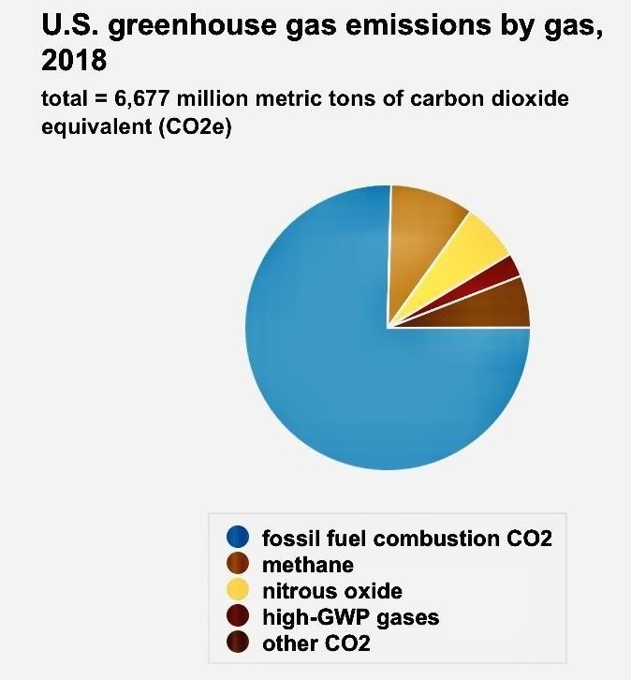

*Fig-4: U.S. greenhouse gas emission by gas, 2018*

*Note: CO2 emission is based on 100-year global warming potential*

Other greenhouse gases: Several other GHGs released as a result of human activities are included in the U.S. and international GHG emissions estimates:

* Methane (CH4) from landfills, coal mining, agriculture, petroleum operations.
* Nitrous oxide (N2O), which comes from the use of nitrogen fertilizers and some methods of industrial and waste treatment and fossil fuel combustion.
* Gases with high global warming potential, which are commercial man-made gases.
* Nitrogen trifluoride
* Hydrofluorocarbons
* Sulphurhexafluoride

About 19 percent of overall U.S. anthropogenic GHG emissions in 2018 were the cumulative emissions of all other greenhouse gases.

### Microplastics

Petroleum has made it possible to use plastics to manufacture a large variety of vast amounts of consumer goods at incredibly low manufacturing costs. It is normal to have single-use plastics and incorrect disposal. The mass of plastic is not recycled, and over time it breaks into smaller and smaller pieces. In air, water and soil samples obtained from virtually anyplace on the earth's planet, and even progressively within biological samplings, microplastics are detectable. Long-term impacts of plastic waste environmental accumulation are under experimental study but are largely unclear to date.

### Oil Spills

An oil spill is the leakage, due to human action, of liquid petroleum hydrocarbons into the atmosphere, in particular aquatic environments, which is a source of contamination. The word typically refers to spills of marine oil, where oil is spilled into the ocean or coastal waters, but spills can occur on land as well. Oil leaks may be caused by the discharge of crude oil from tankers, tanks, trains, offshore platforms, fracking rigs and wells, as well as by the discharge of refined petroleum products (such as gas, diesel) and their by-products, by heavy fuels used by large vessels, such as bunker fuel, or by the discharge of some oily waste or waste oil.

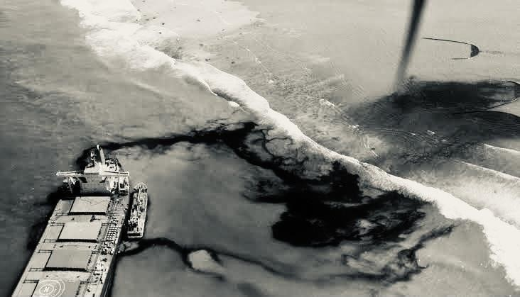

*Fig-5: Mauritius oil spill (July 25,2020), the oil tanker MV Wakashio carrying nearly 4,000 metric tonnes of oil ran aground on the coral reef on the southeast coast island.*

Mauritius oil spill, Lakeview Gusher, the oil spill of the Gulf War, and the oil spill of the Deepwater Horizon are big oil spills. Spilt oil dissolves the bird plumage and mammalian fur structure, diminishing its insulating potential and leaving them more susceptible to changes in temperature and even less buoyant in the sea. It is hard to clean up and rebuild from an oil spill and relies on many factors including the type of oil released, the water temperature (affecting precipitation and biodegradation), and the kinds of coastlines and beaches involved. The persistent inputs of oil and gas residues and the rate at which the atmosphere may clean itself are other influences affecting the rate of long-term pollution. Spills can take several weeks, months or even years to wipe up.

### Acid Rain

The combustion mechanism is responsible for the high production of acid rain in gasoline, coal and wood. Combustion, combined with sulphur dioxide from the sulphur in the gasoline, produces an elevated level of nitrous oxide. To produce acid rain, these by-products mix with water in the air. Improved levels of nitrates and other acidic compounds have a direct influence on the pH level of the precipitation. Data samples from the United States and Europe during the last 100 years were analysed and revealed an increase in combustion emissions of nitrous oxide. The pollutants were high enough for the rainfall to be acidified. There are detrimental effects on the wider world from acid rain. Acid rain can destroy plants, for instance, and can kill fish by acidifying streams. Acid rain also kills coral reefs. Acid rain also allows machines and buildings to become corrosive (large quantities of capital) and paleontological structures such as the limestone ruins of Rome and Greece to be slowly demolished.

### Waste Oil

Waste oil is crude that contains not only ingredients for dissolution, but also contaminants from use. Oils such as hydraulic oil, engine oil, braking oils, motor oil, crankcase oil, gear box oil and synthetic oil are found in some examples of waste oil. Waste oil has much of the same concerns associated with natural hydrocarbons. The oil travels through the water table taking such pollutants as benzene with it when waste oil from cars drips out engines along streets and highways. It kills soil as well as drinking water. Rain runoff brings excess oil into rivers and oceans, also poisoning them.

# Petroleum industry engagement on Climate Change

According to a study showing that human emissions of fossil methane have been underestimated by up to 40 percent, the oil and gas industry has had a far worse environmental footprint than previously believed.

Although the study will add to the pressure on fossil fuel industries, scientists has said there is cause for hope because it showed that tighter regulation of the industry and a faster shift to renewable energy could bring a big additional advantage.

According to the United Nations Environment Programme, methane has a greenhouse effect that over a decade is about 80 times more potent than carbon dioxide and is responsible for nearly 25 percent of global heating.

The amount of carbon in the atmosphere has more than increased over the past 200 years, although there has long been lack of certainty as to whether the source is biological, from agriculture, livestock or landfills, or from fossil fuels. There have also been concerns as to what proportion of fossil methane was released naturally and what proportion was fromthe industrial sector.

This reinforces concerns that fossil fuel industries do not fully account for their climate impact, especially with regard to methane, a colourless, odourless gas that is routinely vented into the atmosphere by many plants.

Methane emissions from US petroleum & energy plants were 60 percent higher than those reported to the Environmental Protection Agency in an earlier study.

Fatalities are underreported as well. In 2018, a single blowout at an oil and gas well in Ohio withdrawn more methane over three weeks than was released in an entire year by France, Norway and the Netherlands' petroleum industry. The corporation said at the time that it was unsure about the size of the leak. It was only a year later that the immense scale was revealed when researchers analysed satellite data supported by the European Space Agency.

It also seems that fracking has exacerbated the situation. At the turn of the century, atmospheric methane had begun to flatten out but increased again following a boom of fracking activity in the United States and elsewhere. However the industry continues to say that the energy supply should be used as a "bridge fuel" because it has lower carbon footprint than oil or coal, but this does not allow for methane and other gas spills and flares during mining. About half of all human-induced methane emissions are due to gas, coal and oil production and distribution across the globe. Connect to it all the carbon dioxide that is produced as fossil fuels are burnt, and you don't have to

dig any further for the environment emergency fire seat.

# Effective and technology methods to Control Pollution

In analysing and introducing new design and translation strategy aimed at pollution control, the petroleum exploration and production sector has been pro-active. Previously, improved management practices and operational methods have been described and the objective of this section is to illustrate certain technologies and methods to pollution prevention and reduction.

***Atmospheric emissions:*** Flaring and venting, that provide the most critical source of pollution pollutants in the industry, are the key priorities for mitigating emissions. In order to find prospects for mitigating pollution, several process efficiencies studies have been undertaken by industry. This has contributed to better protocols for process management, construction and maintenance processes being developed. Technological developments in valve design have the ability to minimize fugitive emissions, while combustion efficiency has been enhanced by improved flare design. The recovery of flare gas and improved recovery of NGL have benefited from emerging innovations that have advanced.

In order to minimize emissions as a result of fuel combustion related to power generation, numerous technical measures have been launched. Along with improved turbine maintenance regimes, more powerful gas turbines have been built. Improvements in performance have also benefited from optimization requirements for gas turbines. Other fuel efficiency enhancement developments include: steam injection; combined cycle power generation; delivery of electric power (phase compensation); optimization of pumps and compressors; reuse of excess heat; synchronized, cooperative power generation; and the implementation of concepts of energy conservation.

Certain innovations being developed are aimed at increasing the efficiency of emission: for example, technology for dry low NOx combustion (DLN), technology for selective catalytic reduction (SCR), as well as water and steam. Injection all for the goal of reducing NOx pollution.

***Produced water***: Water produced is the second big waste arising from the oil production process. Since water is produced with the oil generally, there is limited potential for the source to be eliminated. Some progress has however been made in limiting the production of water. Water shut- off technology like diverting gels can provide an effective way to reduce treatment- requiring amounts of water. If appropriate geological formations are accessible, reinjection of produced water, either into the reservoir or into some other formation, may provide a practical and best possible solution.

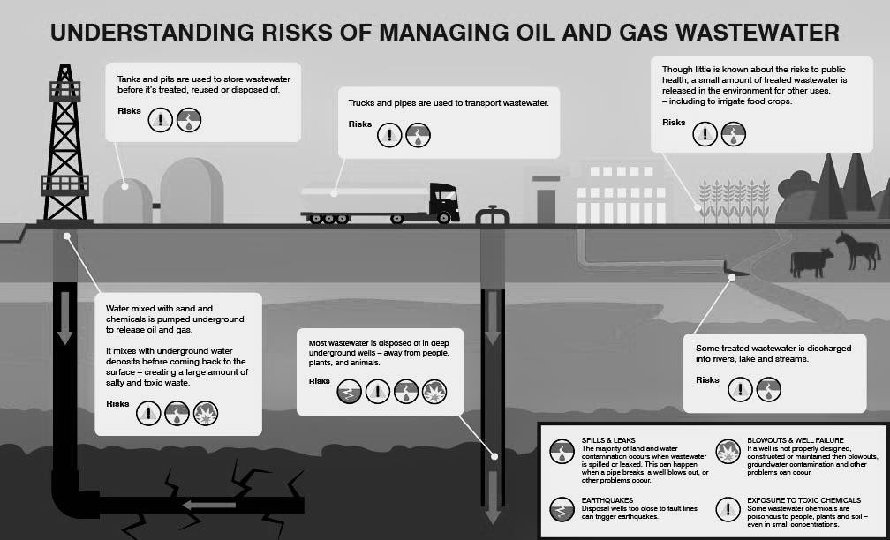

*Fig-6: Understanding Risk of Managing Oil and Gas Wastewater*

Technological advances, especially related to the removal of dispersed oil, are emerging for the treatment of generated water. This include: flotation of skimming/steam; static hydro- cyclones; mechanical centrifugation; and striping of gas. Many of these innovations are in regular service at present or have entered the demonstration testing stage. For future onshore use other methods are currently being studied and include: bio-oxidation and biological treatments; active carbon filtration; solvent extraction; wet oxidation and ozonation.

***Solid wastes***: Several facets of waste management, including an analysis of the mitigation capacity of the source. Opportunities to remove or mitigate waste are however, small because their quantities are mostly partly due to the extent or longevity of operation or the state of degradation of reservoirs. Mainly by method and protocol changes, prospects for mitigation exist. Enhanced solids control systems and modern technologies will minimize the volumes discharged to the atmosphere in the case of drilling fluid discharge. The production of more powerful drill bits will minimize the need for chemical additions, whereas the amount of formation solids/sludge generated can be decreased by gravel packs and screens. Improved processes, controls and maintenance can help to reduce mud.

***Waste treatment and disposal techniques:*** If waste cannot be disposed of by the elimination of contamination, the handling of waste must be achieved by applying another range of measures: avoidance, reuse, recycle, regeneration, treatment and responsible disposal.

The collection of waste treatment and disposal solutions is specifically related to the environment sensitivities, regulatory criteria and available facilities/infrastructure of the geographical region concerned by an area-specific waste management system. The strategy should be written from the viewpoint of the field to provide instructions for each waste stream to be treated. An exploration and processing firm when designing a strategy.

Planning, execution and analysis of local waste management provides reassurance with respect to:

* environmental safety and sustained compliance with regulatory requirement
* continuing development of staff in the field
* The adequacy of the strategy itself
* Propagation of waste volume and contamination. The waste management strategy should be an "evergreen" living plan.

# Oil spill Contingency Planning

The danger, scale, existence and possible effects of oil spills should be carefully investigated by all operations and suitable contingency plans should be established, including reminding the community of any hazards associated. There are various records online. Contingency readiness is focused on risk identification; the preparation and execution of risk management actions; processes for the analysis and monitoring of preparedness; and staff training.

Contingency preparation should promote the quick deployment and productive utilization of the personnel and facilities available to carry out emergency relief operations and sustain them. To ensure preparedness, drills and instruction should be performed annually. Communications with the relevant jurisdictions, local communities, newspapers, nearby operators, contractors and workers should be maintained.

#### *Table: Site or area-specific waste management plan* Step 1: Management Approval

Approval from management and support for the plan should be attained. Management should

be conscious of the timing of the plan and its scope. The goal(s) of the waste management strategy should be developed with strategic outcomes for each goal.

#### *Step 2: Area definition*

The strategy should be unique to the location or region and should provide an overview of the geographical area and the operating tasks discussed

#### *Step 3: Waste identification*

All of the waste produced within the area specified by each exploration and production activity

i.e. processing, fracking, completion/workover, natural gas should be detected by operations staff. Further control measures can be assisted by a brief overview of each waste (sources, portion oil and/or saltwater content and estimated volume).

#### *Step 4: Regulatory analysis*

Examine the laws and regulations of international, regional and host countries to assess the forms of waste for which management activities should be highlighted. Waste forms for which management criteria are not clearly specified by the regulations should also be listed.

#### *Step 5: Waste categorization*

A physical, chemical and toxicological characteristics of each waste should be identified by means of the Materials Safety Data Sheet (MSDS), records on the suppliers, process expertise,

historical data or laboratory study. Wastes should be categorized according to their wellbeing and risks to the environment.

#### *Step 6: Evaluation of waste management and disposal options*

Option for waste management should be collected for each waste, and available solutions listed. Appropriate operations staff and management should review each alternative. Assessment should include: environmental concerns; location, limitations of engineering, regulatory constraints, viability of operation, economics; probable long-term liability, etc.

#### *Step 7: Waste minimization*

Waste, reduction in volume or contamination, recycle and reclaiming, or disposal should be measured. To reflect any minimization activities adopted, the waste management strategy should be updated to reflect.

#### *Step 8: Selection of preferred waste management practices*

For the particular operation and site, pick the best practice. Life-cycle review should be considered, covering use, handling, care, transport and disposal.

#### *Step 9: Implementation of an area waste management plan*

Waste treatment and recycling solutions can be compiled into one detailed waste management plan for each waste. Waste management activities, and waste definitions, should be summarized, showing the waste management and disposal practice picked.

#### *Step 10: Plan review and update*

An evolving phase is the successful handling of waste. The strategy should be checked asnew practices or options for waste management are found. A procedure should be developed to review and amend the waste management strategy and procedures should be updated to accommodate emerging technology, requirements or regulations.

# Contingency Plan

* + First identify the risks and the objectives
  + Build a Response Plan
  + Set up the communications and accountability
  + Determine resources requirement
  + Set up the actions plan
  + Define trainings and exercises requirements
  + Provides data directories and supporting information

In the case of a spill, the arrangements should specifically define the appropriate actions: the communications network, the operational structure, the specific roles of key rescue staff, along

with the reporting protocols to the responsible authority. The proposal should define fragile and critical sites specifically and discuss the question of the handling of recovered material, hazardous waste and rubble.

As required under the environmental management scheme, responsibility for contingency plans, their execution, preparation and exercise, and periodic examination and review should be explicitly assigned to site employees.

# Recommendations for Emission Reduction

Emissions are produced by the oil petroleum industries at several stages of operations. Such pollution can dramatically affect air quality and have a short-term and long-term effect on the health of employees and people living near and in the same area. The best approach to change the situation is to examine in depth the mechanism and activities and define areas where control steps to minimize these pollutants can be taken.

Proper ventilation and flaring technology, for instance, can minimize natural gas losses, and this has been investigated and quantified as seen in Table

***Table:*** *Potential national declines in federal onshore leases from expanded use of ventilation and flaring technology mitigation technologies:*

### Emission sources Potential reduction (BCF) Percentage of total volume EPA

**Estimated vented and flare**

Glycol dehydrators 5.7- Install vapor recover devices 4.5

Well completions 14.6 – Expand use reduced emission 11.7

completions

Gas well liquid unloading 7.1- Expand uses smart automated plunger 5.7

Pneumatic device Oil and 9.7- Use low bleed devices 7.7

condensate storage tanks 10.2- Install vapor recovery units 10.2

Through employing steps such as vapor recovery systems and utilizing double seals instorage facilities, emissions from storage can be significantly minimized. A typical maintenance concern is leaks due to defects or seal problems in equipment, and this can be reduced by regularly inspecting or maintaining the equipment with a leak detection and repair program. Likewise, by careful design, processes, and good maintenance standards, fugitive emissions can be minimized. Lower NOx burners are present in some of the processes using combustion, and SOx emissions can be reduced by desulfurization of fuels or by routing sulphur-containing fuels to units fitted with SOx pollution control technologies. The efficiency of combustors and furnaces should be increased, as it will also mitigate pollution.

For the reduction of NOx, these are some of the best available techniques (BATs). They require the use of low NOx burners, the use of gaseous gasoline, selective elimination of catalytic, and energy integration. Using low NOx burners decreases the temperature of the flame and eliminates the output of NOx. In order to decrease combustion temperatures, a few burners employ flue gas recirculation. Replacing liquid fuels for gaseous fuels that are nearly N2 free

also helps to lower NOx. Another way to accomplish lower emissions is selective catalytic reductions, using V2O5/TiO2 catalysts where nitrogen oxides react to form nitrogen and water.

# Conclusions

Growing population levels lead to increasing energy consumption, especially from fossil fuels. The government improved oil and gas output to supply this such as mining efforts to achieve strong new production. For this region, this operation has the benefit of energy supply, but has more environmental drawbacks. Air, water and soil contamination will be caused by emissions generated from land clearing, exploration, development and delivery. For the social element and variety of flora fauna, the other side will be impact.

Upstream systems of the oil and gas sector have several steps in the processing of oil and gas transactions. The air effect will allow flaring and exploration and development processes to be affected by air pollution, global warming, ozone depletion, and decline of human health. The effect of water would be accompanied by degradation of water quality as oil leaked, water generated, and mud/sludge. Due to the residue from leaked oil and mud or sludge, the soil impacts are close to the water effects.

Refineries and petrochemical industries may impact air quality in accordance with various different industrial activities. Pollutants such as VOC (Volatile Organic Compounds), particulate matter, greenhouse gases can be emitted and contribute to the creation of ozone, primarily from isolation, conversion, handling, combustion, storage, abrupt leaks from process machinery, or also from auxiliary sources such as cooling towers, furnaces, and recovery units of sulphur. Such emissions decrease air quality, quantified by Air Quality Indexes, and air quality control is crucial to solving this issue and mitigating the effect.

It is not possible to determine for certain the direct contribution of oil refining emissions to health effects, as many other factors, such as population lifestyles and habits, and other sources of emission levels, must also be considered before drawing any firm conclusions. Before we can infer more from the correlations between individual pollution and health outcomes, this takes more study and comprehensive trials, although it is clear that any positive impacts on air quality can be helpful. It is desirable to carry out policy studies using mathematical modelling to optimize the advantages of current regulations and strategies to improve air quality. These mathematical modelling allows for the study of the distributional effects of various pollution control scenarios. This might thus make it possible to conclude whether such proposals for lowering pollution could lead to small or major changes.

Social effect can be affected by social awareness, work vacancies and the change of local society. The last is flora fauna effect. Reducing vegetation quantityand consistency because of land clearing and flaring heat. Light, land clearance and flaring heat affect the change in animal metabolism.

# References

* + Das, Pulak (2014). Environmental management in oil and gas upstream industry in India.

*Journal of Industrial Pollution Control, 30(1), 59-66.*

* + Ragothaman, Aiswarya, Anderson, William A. (2017). Air quality impacts of petroleum refining and petrochemical industries. *Environments – MDPI, 4(3), 1-16,* DOI- 10.3390/environments4030066
  + U.S. Department of Energy. Office of Oil and Natural Gas (2019). Natural Gas Flaring and Venting : State and Federal Regulatory Overview , Trends , and Impacts. *U.S. Department of Energy, June, 72.*
  + Mardhika, Sapto Sari (2018). Determine Environment Impacts in Upstream Processes of Oil and Gas Industries. *E3S Web of Conferences, 73, 8-1,* DOI: 10.1051/e3sconf/20187305008
  + Publication, Unep Technical. Environmental management in oil and gas exploration and production.
  + Environmental, Health, and Safety Guidelines for Onshore Oil and Gas Development, International Finance Corporation.
  + Sharif MD, Ahammad NVR, Nagalakshmi, Reddy S, Srigowri G, Vasanth, Sankar K, Uma (2017). Drilling Waste Management and Controlthe Effects. *Journal of Advanced Chemical Engineering, 07(01), 1-9,* DOI: 10.4172/2090-4568.1000166
  + Wang, Shuguang Xu, Yan Lin, Zhaofeng Zhang, Jishi Norbu, Namkha Liu, Wei(2017). The harm of petroleum-polluted soil and its remediation research. *AIP Conference Proceedings, 1864, August,* DOI: 10.1063/1.4993039
  + [https://www.energydigital.com/oil-and-gas/heat-turns-flaring-and-venting- greenhouse-gases](https://www.energydigital.com/oil-and-gas/heat-turns-flaring-and-venting-greenhouse-gases)
  + <https://en.wikipedia.org/wiki/Environmental_impact_of_the_petroleum_industry>
  + <https://www.capp.ca/energy/world-energy-needs/>